Knee OA Classification Using Bone Distance

Yashwanth Varre

*3rd Semester, Seidenberg School of Computer Science, and Information Systems, Pace University, NY.*

[Yashwanthvarre02@gmail.com](mailto:Yashwanthvarre02@gmail.com)

**Abstract: - The most common form of arthritis in the knee is osteoarthritis (OA). This is most seen in people of age group above 60 years old. Osteoarthritis is a form of arthritis that primarily affects the cartilage in the joints. Osteoarthritis is a degenerative joint condition in which the size of cartilage reduces gradually. This cartilage helps the bones for smooth movement so that they do not rupture causing severe pain or swelling of bones. This paper presents a method using image processing techniques to calculate the distance between femur and tibia bones which is used as input for the classification of Knee OA. The estimation of distance between the femur and tibia bones plays an important role in determining the severity level of OA.**

**This research uses a dataset of segmented MRI images which are used as input for extracting distance feature of each patient. The distance feature and V03KLGrade metric are used as input for weka software which builds classification machine learning model. This model helps us to predict if the patient has Osteoarthritis or not.**

**Keywords: Osteoarthritis, Cartilage, MRI (Magnetic Resonance Imaging), image processing, machine learning.**

1. INTRODUCTION

Osteoarthritis is a degenerative joint condition in which the size of cartilage reduces gradually. Osteoarthritis mainly effects the knee part of the body. Cartilage is a thin, ultra-slippery layer of high-quality hyaline material that covers the ends of bones and easy joint movement. Healthy cartilage helps in easy movement of femur and tibia bones which prevents them from rubbing. More than 71 million people suffers Osteoarthritis worldwide [1]. This condition mainly seen in the age group of above 60 years old and it is possibly seen in between the age groups of 18-60 due to different reasons like genetic conditions, aging, athletics etc. The number of people affected due to Osteoarthritis increases as they get older. OA prevalence is estimated to be 43% in women and 25% in men [2].

The anatomy of the knee can be well delineated using MRI, which allows for the quantification of different

sections of the articular tissues that are important to arthritis. X-ray imaging is only used to get a view of the bones, but the magnetic resonance imaging detects the abnormalities of the bone structures. MRI scans are much better at detecting the early abnormalities compared to X- rays So MRI images are recommended for research purpose.

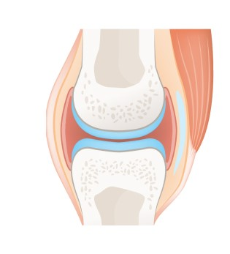

Figure 1: - Knee bone with healthy cartilage

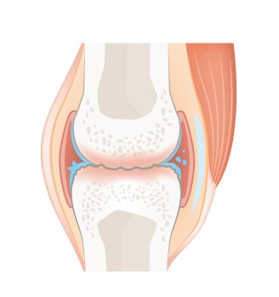

Figure 2: - Knee bone with worn out cartilage (Osteoarthritis)

In this paper a simple method is developed for the classification of Osteoarthritis. The algorithm calculates the space between the femur and the tibia bones using distance as the main feature. Using weka software a machine learning model is built for the classification of Knee Osteoarthritis using V03KLGrade.

1. BLOCK DIAGRAM

MRI knee images in sagittal view are taken for experimentation. The image processing steps of the present work are as shown int the following block diagram.

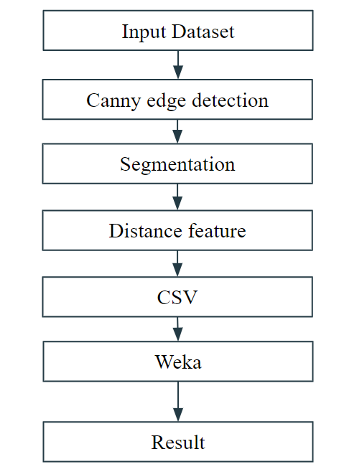

Figure 3:- Block diagram

First the 2D knee bone MRI images are taken as input for the algorithm. The edges of the images are extracted using Canny edge detection technique. Canny edge detection technique is mainly recommended because it reduces the amount of data to be processed compared to other edge detection techniques. After extraction of edges further segmentation is done i.e., separating the femur and tibia bones. The distance between the two bones is calculated using a distance measure i.e., Euclidean distance.

The distance measure along with V03KLGrage label is converted into a CSV file and it will be given as input to weka software which helps us build machine learning models without coding. We use Multilayer perceptron as the

ML model with cross validation folds of 10. The result will be the classification result with Accuracy, ROC area, TP rate, FP rate, Precision, Recall, F-Measure, MCC, PRC area.

1. METHODOLOGY

The dataset contains more than 30000 2D Knee bone MRI images gathered form 193 patients. Originally 3D knee MRI images are segmented using U-net into 2D binary images. U-net is an artificial neural network method which is primarily used in bio medical image segmentation. For each patient there are around 160 images in the dataset which are used to evaluate patient’s condition.

The images which are given as input to the algorithm are binary images in the PNG image format so, there is no need for further preprocessing the images. Figure4 shows the input image.



Figure 4:- Input Image

Canny edge detector is applied to the input image to find the boundaries of femur and tibia bone. Figure5 shows the Canny edge detected Image.

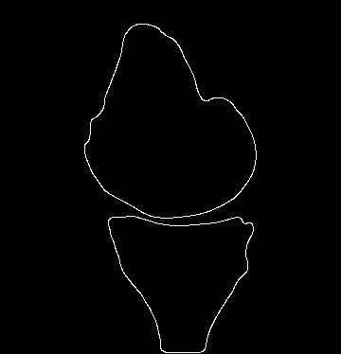

Figure 5:- Canny edge detected Image

Further segmentation is done on the edge detected image by taking two largest blobs in the image which will be femur and tibia bone, respectively.

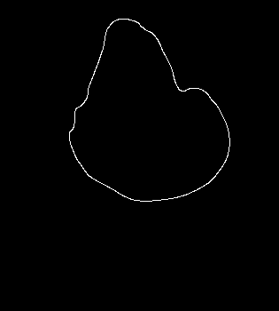

Figure 6:- Object 1 Femur bone

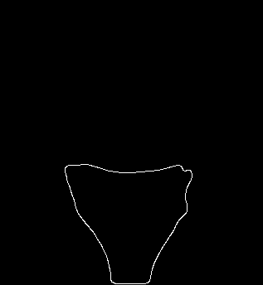

Figure 7:- Object 2 Tibia bone

The pixel values of femur and tibia bone are stored saperately and distance is measured beteen both the objects using Euclidean distance as the distance measure and choose the minimum value of the distance vector. Each patients contains around 160 images for which you get 160 distance measure. Take the average of the measures that will be your final distance measure for a single patient Apply the above process to all the 193 patients. For each patient you get a distance vector. Take the average of that distance vector and consider it as a distance feature for that patient id. Then do the same for all the patients for which you get 193 distance features. Store them in a vector and convert them into CSV file format which we be given as input to the weka doftware. The CSV file should contain distance measure, ID of the

patient, and V03KLGrade which acts as a nominal value i.e. label which is used for supervised learning.

when you plot the pixel values of distance measure you will get the following image the distance between the point gives you the distance feature of the image.

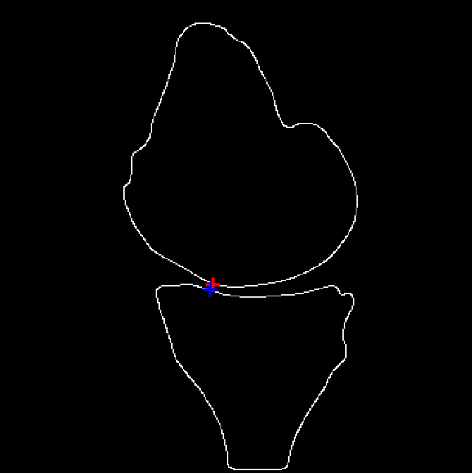

Figure 8:- Plotting of Pixel values of distance measure

After converting the distance features into CSV format, it is given as input to weka software. This a software developed by University of New Zealand which helps us to build machine learning models without coding. We choose the CSV file as input and feed it to weka software. We choose Multilayer perceptron model as the function of classification for our model with the cross validation of 10 which will give us classification result.

1. EXPERIMENTAL RESULTS

In this work a methodology for finding the distance between the femur and tibia is performed using Euclidean distance as the distance measure. Number of combinations were performed to increase the accuracy among them Average distance measure accomplished greater accuracy and ROC area than the others. Results are tabulated in Table.1 for Minimum distance and Average distance measure.

|  |  |  |
| --- | --- | --- |
| Case | Accuracy | ROC |
| Minimum distance | 63.73 | 0.42 |
| Average distance | 67.87 | 0.52 |

Table 1: - Accuracy and ROC area results of Minimum and Average distance measures

1. CONCLUSION

Image processing techniques are used for segmentation of femur and tibia bones. This method finds the average distance between femur and tibia bones using Euclidean distance as a measure and that distance feature is used as input in weka which helps us build machine learning models without coding. We use Weka for classification of Osteoarthritis using distance vector and V03KLGrade as inputs. V03KLGrade acts as nominal value which gives information about whether a person has Osteoarthritis or not. This method is performed using 2D images. Hence, the outcomes acquired are explicit to specific perspective on MRI. The results were compared with different distance features, but the Average distance measure gave us better results compared to other features. During arrangement, numerous different variables like age, sex and weight must be taken into thought. Anyway, the accuracy of the calculations can be increased by performing more number of case studies.

REFERENCES

1. Measurement of Cartilage Thickness for Early Detection of Knee Osteoarthritis (KOA) Sanjeevakumar Kubakaddi , Dr KM Ravikumar Harini DG, 2013 IEEE Point-of-Care Healthcare Technologies (PHT) Bangalore, India, 16 - 18 January, 2013
2. Bharat S. Mody, ³The Definition of a Successful Total Knee Replacement Differs for Asian and European Patients Current Outcomes and Quality of Life Assessments do not consider Cultural Variations.¥ Orthopedics Today Europe, July/August 2010.
3. Knee Joint Cartilage Visualization and Quantification in Normal and Osteoarthritis, M. S. Mallikarjuna Swamy, M.S.Holi, Proceedings of 2010 International Conference on Systems in Medicine and Biology 16-18 December 2010, liT Kharagpur, India.
4. A Survey on Exploration and Classification of Osteoarthritis Using Image Processing Techniques, Shivanand S. Gornale, Pooja U. Patravali, Ramesh R. Manza
5. Detection of Knee Osteoarthritis by Measuring the Joint Space Width in Knee X-ray Images, Bindushree R, Sanjeev Kubakaddi,, Nataraj Urs, IPASJ International Journal of Electronics & Communication (IIJEC), Volume 3, Issue 4, April 2015.